Homework 5
- All homework must be turned in on PDF format. This can be scanned or typed in any paper size, but the format must be PDF and the file must be readable. This document can be modified for your homework submission. An additional homework template is available on Canvas to assist you in creating your answers, and content from lecture notes can be used.
- All final answers must be circled or in green.
- All homework must have a name on the top of every page.
- Submission errors (not in PDF, illegible, etc.) will not be re-graded.

Problem 1 (2 pts each)
Minimize the following functions using K-maps into their minimal SOP form.
- $f\left(a,b,c\right)=abc+\overline{a}bc+\overline{a}\overline{b}c=∑m\left(1,3,7\right)=\overline{a}c+bc$
 | $$bc$$
$$a$$ |  | 1 | 1
 |  |  | 1

- $f\left(a,b,c,d\right)=\overline{a}b\overline{c}\overline{d}+\overline{a}b\overline{c}d+\overline{a}bc\overline{d}+a\overline{b}cd+ab\overline{c}d=∑m\left(4,5,6,11,13\right)=\overline{a}b\overline{d}+b\overline{c}d+a\overline{b}cd$
 | $$cd$$
$$ab$$
 | 1 | 1 |  | 1
 |  | 1
 |  |  | 1

Problem 2 (2 pts)
Determine which of the following functions are equivalent without using Boolean reduction (i.e., using K-maps). Hint: plot the implicants onto K-maps.
$$f_{1}\left(A,B,C,D\right)=AC+BD+A\overline{B}\overline{D}$$
$$f_{2}\left(A,B,C,D\right)=A\overline{B}\overline{D}+AB+\overline{A}B\overline{C}$$
$$f_{3}\left(A,B,C,D\right)=BD+A\overline{B}\overline{D}+ACD+ABC$$
$$f_{4}\left(A,B,C,D\right)=AC+A\overline{B}\overline{C}\overline{D}+\overline{A}BD+B\overline{C}D$$
$$f_{5}\left(A,B,C,D\right)=(B+\overline{D})(A+B)(A+\overline{C})$$
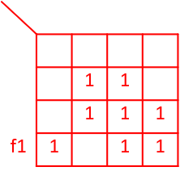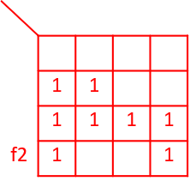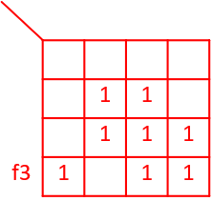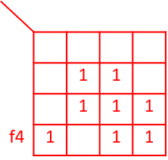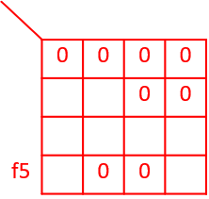
F1, f3, and f4 are the same function, as are f2 and f5.

Problem 3 (2 pts each)
Minimize the following functions using a K-map. Express your answers in minimal SOP form.
- $f\left(A,B,C,D\right)=∑m\left(0,3,6,7,12,13\right)+d\left(1,8,9,10\right)$
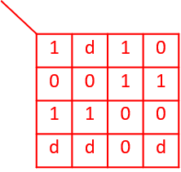
One of these two terms must be selected.
$$d=1$$
$$c=1$$
$$a=1$$
$$b=1$$
$$ab$$
$$cd$$
$$f\left(A,B,C,D\right)=A\overline{C}+\overline{B}\overline{C}+\overline{A}BC+(\overline{A}\overline{B}D+\overline{A}CD)$$

- $f\left(A,B,C,D\right)=∏\left(0,1,2,6,7,10,11,12,13\right)⋅D\left(3,8,9\right)$
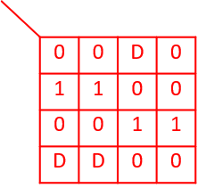
$$d=1$$
$$c=1$$
$$a=1$$
$$b=1$$
$$ab$$
$$cd$$
$$f\left(A,B,C,D\right)=ABC+\overline{A}B\overline{C}$$

